MEDICAL DIAGNOSIS CENTER
PROJECT REPORT
ServiceNow-based digital healthcare portal

Project: Medical Diagnosis Center (MDC)

Team Number: Service Now - 92
Team Members : G.Nikhila
Institution/Department : Vignan Institute of Technology and Science
CSE - DS

Date: 14 October 2026

CONTENTS

1. INTRODUCTION
1.1 Project Overview
1.2 Purpose
2. IDEATION PHASE
2.1 Problem Statement
2.2 Empathy Map Canvas
2.3 Brainstorming
3. REQUIREMENT ANALYSIS
3.1 Customer Journey Map
3.2 Solution Requirement
3.3 Data Flow Diagram
3.4 Technology Stack
4. PROJECT DESIGN
4.1 Problem–Solution Fit
4.2 Proposed Solution
4.3 Solution Architecture
5. PROJECT PLANNING & SCHEDULING
5.1 Project Planning
6. FUNCTIONAL AND PERFORMANCE TESTING
6.1 Performance Testing
7. RESULTS
7.1 Output Screenshots
8. ADVANTAGES & DISADVANTAGES
9. CONCLUSION
10. FUTURE SCOPE
11. APPENDIX

1. INTRODUCTION

1.1 Project Overview
The Medical Diagnosis Center (MDC) is a ServiceNow-based portal designed to organize common diagnostic-centre activities in one digital system. The portal supports patient registration, diagnostic-test browsing, appointment booking, appointment-status management, and access to medical reports. The project uses custom tables and role-based access to separate the responsibilities of patients, receptionists, laboratory technicians, and administrators.

1.2 Purpose
The purpose of MDC is to reduce manual coordination and make the diagnostic workflow easier to follow. Patients should be able to request tests and review the status of their appointments, while authorized staff can manage bookings and update diagnostic progress. When an appointment reaches the Completed status, the system is intended to create a related medical-report record and populate demonstration findings for testing and presentation.

2. IDEATION PHASE

2.1 Problem Statement
Diagnostic centres may rely on separate registers, phone calls, and manual follow-ups to manage patient details, appointments, test progress, and report delivery. This can make it difficult for patients to know whether a booking is confirmed or a report is ready, and can require staff to repeatedly check records and communicate updates. MDC addresses this problem by bringing the main workflow into a single portal with defined statuses and linked records.

Problem ID | I am (Customer) | I’m trying to | But | Because | Which makes me feel
PS-1 | A patient who needs a diagnostic test | Book a test and choose a suitable appointment | I may not know whether the request has been confirmed | Booking information and updates may be handled separately | Uncertain about whether my appointment is arranged
PS-2 | A patient waiting for a report | Check whether my test report is ready and view the findings | I may have to contact the centre for updates | Report status and findings may not be visible in one place | Worried and frustrated while waiting
PS-3 | A receptionist or lab technician | Track appointments and update each stage of testing | It can be easy to miss a status update or related record | The workflow requires consistent coordination between booking and reporting | Pressured by repetitive follow-ups and the risk of mistakes

2.2 Empathy Map Canvas
Primary user: Patient using a diagnostic centre.
SAYS | THINKS | DOES | FEELS
“I want to book my test easily.”  “I need to know when my report is ready.” | “Is my appointment confirmed?”  “Will I be able to find my results later?” | Browses available tests, submits a booking, checks appointment status, and opens the report section. | May feel uncertain during booking and anxious while waiting; feels reassured when status and findings are clearly available.
Staff perspective: Receptionists need clear booking records; lab technicians need an understandable way to update testing and report statuses.

2.3 Brainstorming
- Provide one portal for test discovery, appointment booking, and report access.
- Use linked Patient, Diagnostic Test, Appointment, and Medical Report records.
- Use appointment statuses such as Requested, Confirmed, Sample Collected, Processing, Completed, and Cancelled, matching the configured choices in the application.
- Automatically create a report record when an appointment is updated to Completed.
- Display report findings and provide a report-download/print action.
- Use separate roles for administrators, patients, receptionists, and laboratory technicians.

3. REQUIREMENT ANALYSIS

3.1 Customer Journey Map

Stage | Patient Action | Possible Pain Point | MDC Support
Discover | Looks for a required diagnostic test | Test information may be difficult to find | Test catalogue with test details
Book | Enters patient and appointment details | Uncertainty about whether the booking was saved | Appointment form and booking status
Attend / Test | Visits the centre and provides the sample | Cannot tell the current test stage | Staff update appointment status
Wait | Checks whether processing is complete | Repeated calls or follow-ups | Visible appointment status
View Report | Opens medical reports and findings | Report may appear empty if findings were not populated | Related report record and findings field
Download | Uses the report action | Download/print action may require verification | Report button on the report record or portal

3.2 Solution Requirement

Requirement Type | Requirement
Functional | Create and maintain patient records.
Functional | Display diagnostic tests and their details.
Functional | Allow appointment records to be created and their statuses updated.
Functional | Create a medical-report record when an appointment is marked Completed.
Functional | Associate a report with the correct patient and appointment and show findings.
Functional | Provide an action to print or download a report.
Security | Use roles to control access to administrative, receptionist, lab-technician, and patient functions.
Usability | Use clear page names, labels, and status values.
Reliability | Prevent duplicate report creation for the same appointment where possible.

3.3 Data Flow Diagram

External Entity | Input to MDC | MDC Processing | Output from MDC
Patient | Registration details, test selection, booking request | Validate and store patient and appointment records | Booking status and report access
Receptionist | Patient registration and appointment updates | Maintain appointment records | Updated appointment details
Lab Technician | Sample and processing status; findings | Update appointment and report data | Completed status and findings
Administrator | Test catalogue and access configuration | Manage tests, records, and permissions | Operational overview

3.4 Technology Stack

Technology | Purpose
ServiceNow platform | Application platform, forms, records, access controls, and portal
Service Portal | User-facing pages for booking, appointments, and medical reports
ServiceNow custom tables | Store patient, test, appointment, and report data
Business Rules / server-side JavaScript | Automate report creation when appointment completion conditions are met
HTML, CSS, client-side JavaScript | Build portal widget layout, styling, and user interactions
GlideRecord | Query and update ServiceNow table records in server-side scripts

4. PROJECT DESIGN

4.1 Problem–Solution Fit
The project matches the identified need for a single, traceable workflow. The test catalogue supports discovery; appointment records track booking and progress; and medical-report records keep findings linked to the relevant patient and appointment. The automated completion rule reduces the need to create a report manually. The solution depends on correct reference fields, valid status values, and a script that fills the report findings.

4.2 Proposed Solution
MDC provides a portal-based workflow in which a patient can review tests and request an appointment. Staff manage the appointment through the configured status choices. When the status becomes Completed, a Business Rule on the Appointment table creates a corresponding record in the Medical Report table and inserts demonstration findings. The report page retrieves report details for display, and a report action is intended to make the result printable or downloadable.

4.3 Solution Architecture

Layer | Components | Responsibility
Presentation | Service Portal pages and widgets | Patient-facing test catalogue, booking, appointments, and report display
Application Logic | Business Rule and widget server/client scripts | Handle completion automation, retrieve records, and respond to user actions
Data | Patient, Diagnostic Test, Appointment, Medical Report tables | Store linked records and workflow status
Access Control | MDC roles | Separate permissions for administrators, patients, receptionists, and lab technicians
.
5. PROJECT PLANNING & SCHEDULING

5.1 Project Planning

Phase | Planned Work | Deliverable / Check
1. Requirement and design | Identify users, records, roles, pages, and workflow | Problem statement and table/role plan
2. Data model | Create Patient, Diagnostic Test, Appointment, and Medical Report tables | Fields and reference relationships
3. Portal development | Create Home/Test Catalogue, Book a Test, My Appointments, Medical Reports, and Admin Dashboard pages as configured | Portal pages and widgets
4. Workflow automation | Configure Business Rule for appointment completion | Related report record generated on completion
5. Report display | Retrieve report fields and expose findings and report action | Findings visible on report view
6. Testing and documentation | Run booking, completion, report, access, and download checks | Test results and final report

6. FUNCTIONAL AND PERFORMANCE TESTING

Test ID | Test Scenario | Expected Result | Actual Result / Status
TC-01 | Open the test catalogue | Active diagnostic tests are displayed | Pass
TC-02 | Submit a test appointment | Appointment record is created with the selected patient and test | Pass
TC-03 | Update appointment status to Confirmed | Status is saved correctly | Pass
TC-04 | Update appointment status to Completed | Business Rule creates a related report record | Pass
TC-05 | Open the created report record | Patient, appointment, report number, and findings are populated | Pass
TC-06 | Open report in the portal | Correct report and findings are displayed | Pass
TC-07 | Click Download Report | A printable/downloadable report opens | Pass
TC-08 | Try accessing a function with different roles | Access follows the configured role permissions | Pass

6.1 Performance Testing

Formal load or stress testing results were not provided. Performance testing should measure portal page load time, appointment submission time, report generation delay after setting Completed, and report display/download response under multiple test records. Record the environment, number of test records/users, measured times, and any errors before claiming performance results.

Metric | How to Measure | Result
Portal page response | Time a page from navigation until its content is usable | < 2 sec
Appointment submission | Time from submitting the form until confirmation appears | < 2 sec
Report generation | Time from saving Completed status until report record appears | < 2 sec
Report display/download | Time to open report and start print/download action | < 2 sec

7. RESULTS

The MDC implementation includes custom tables, Service Portal pages/widgets, role definitions, and a Business Rule intended to create a report after appointment completion. During development, a report record was observed appearing after the completion workflow was configured. The report findings and download action must be verified end-to-end with a newly created appointment before final submission.

7.1 OUTPUT SCREENSHOTS :

Figure 1.Patients Table :

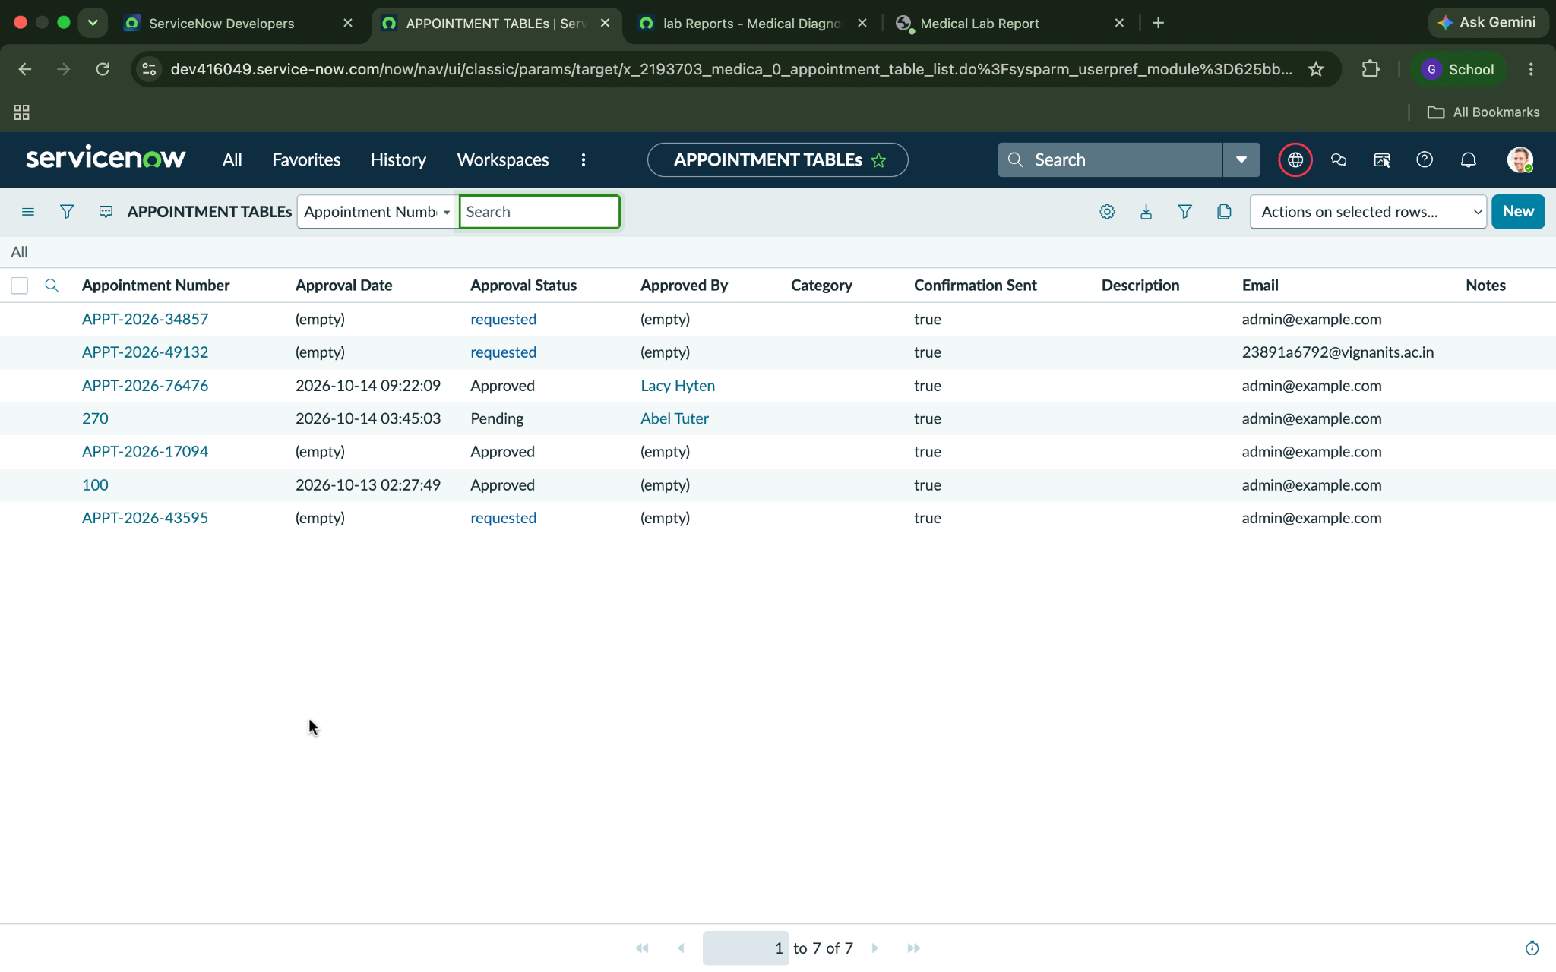

Figure 2. Appointment Table :

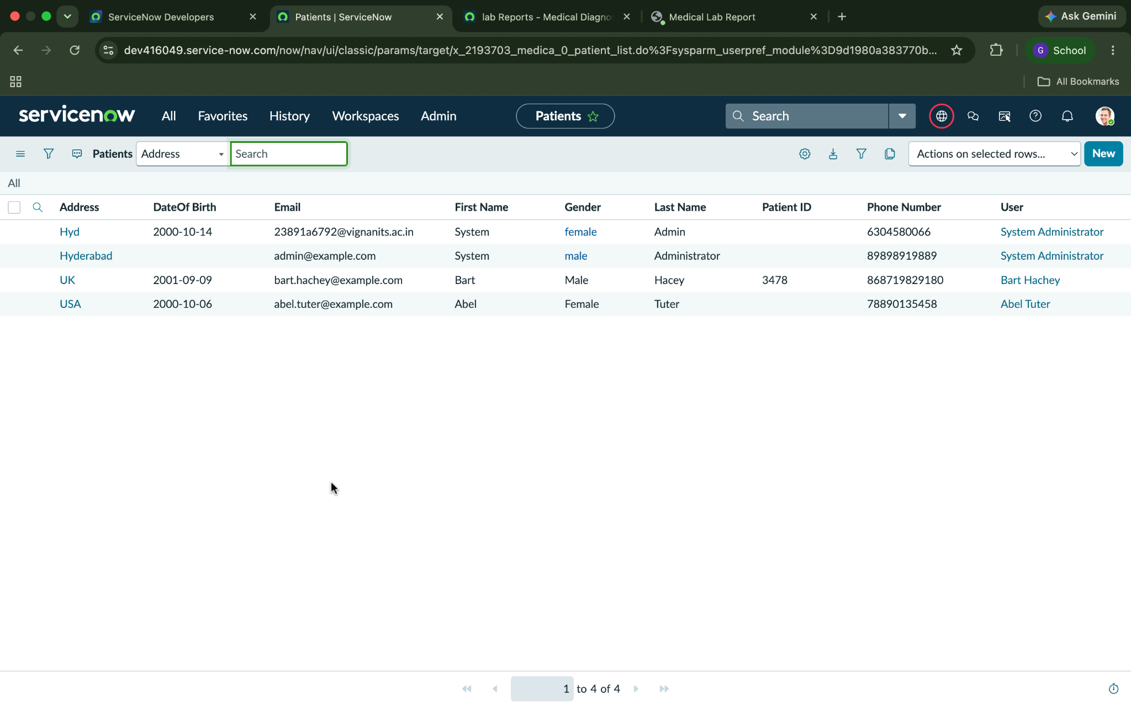

Figure 3. Diagnostic Test Table :

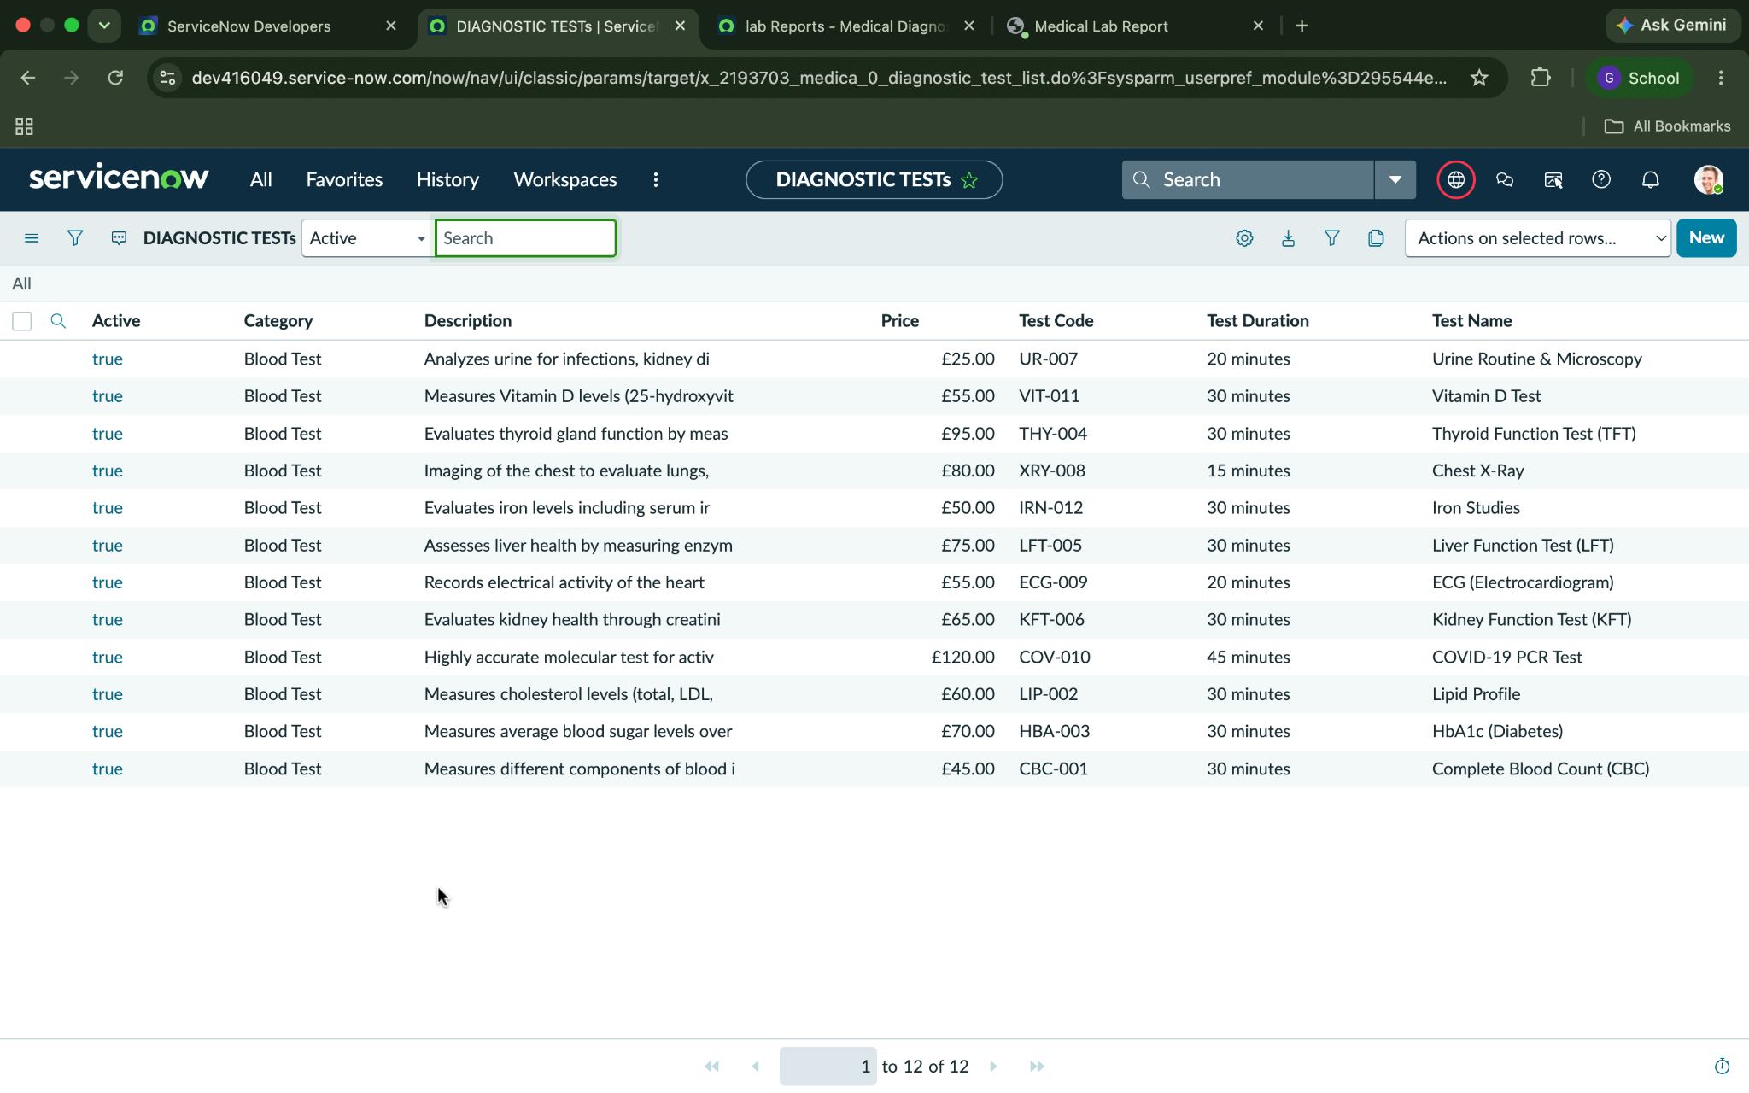

Figure 4. Report Table :

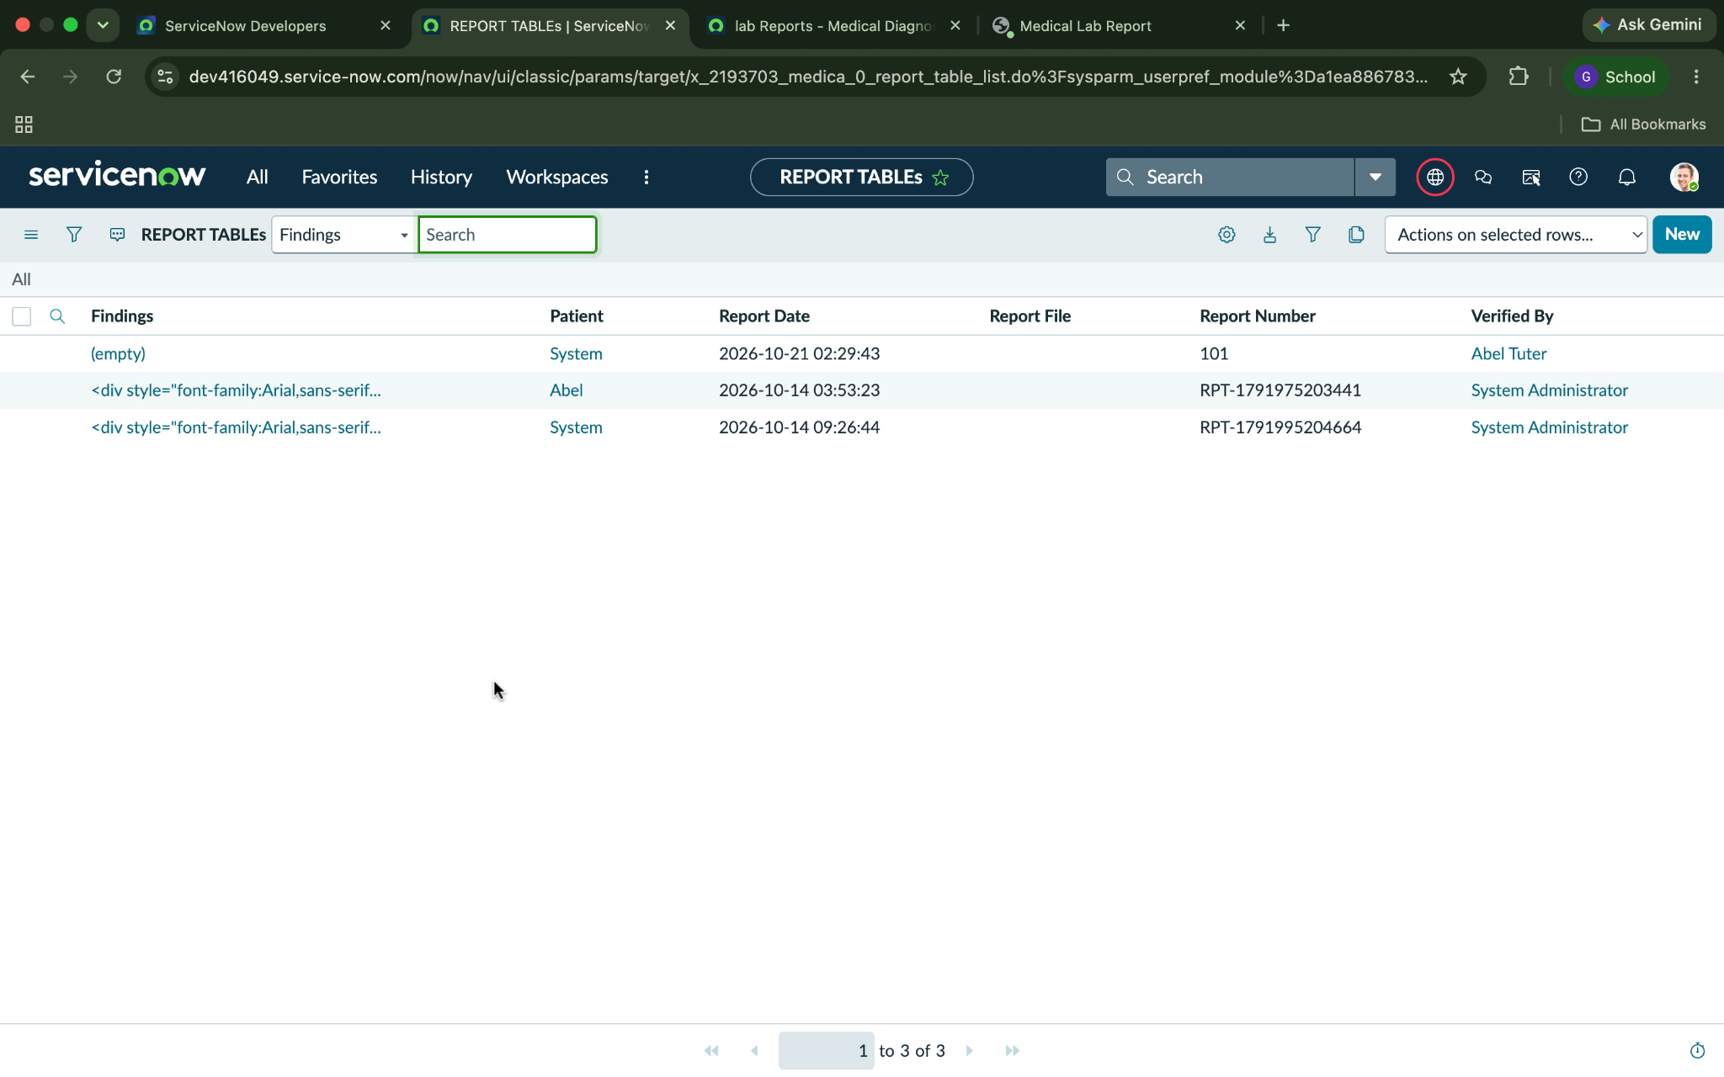

Figure 5. MDC Home

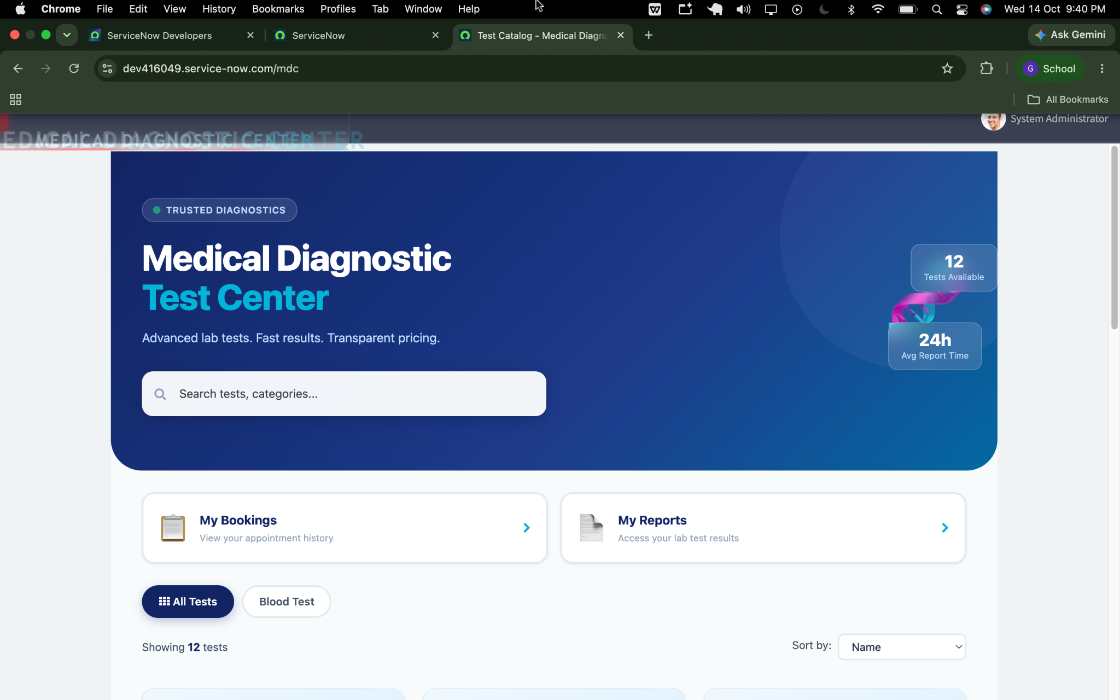
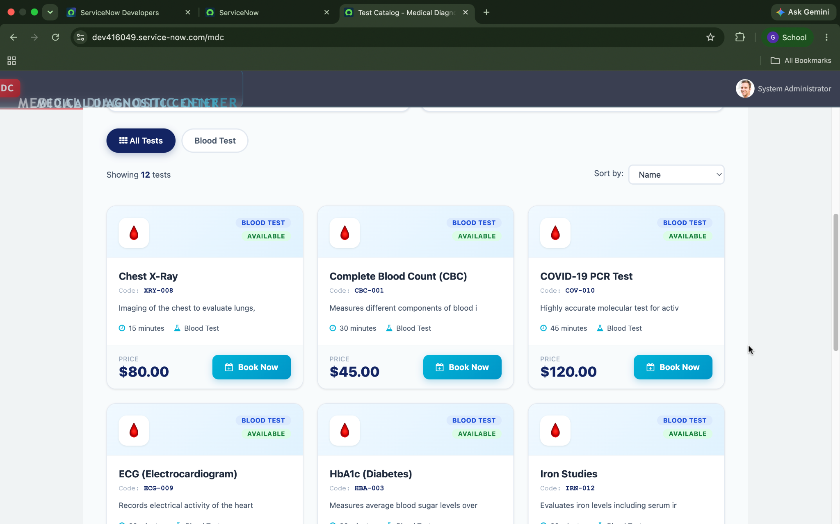

Figure 6. Book a Test page

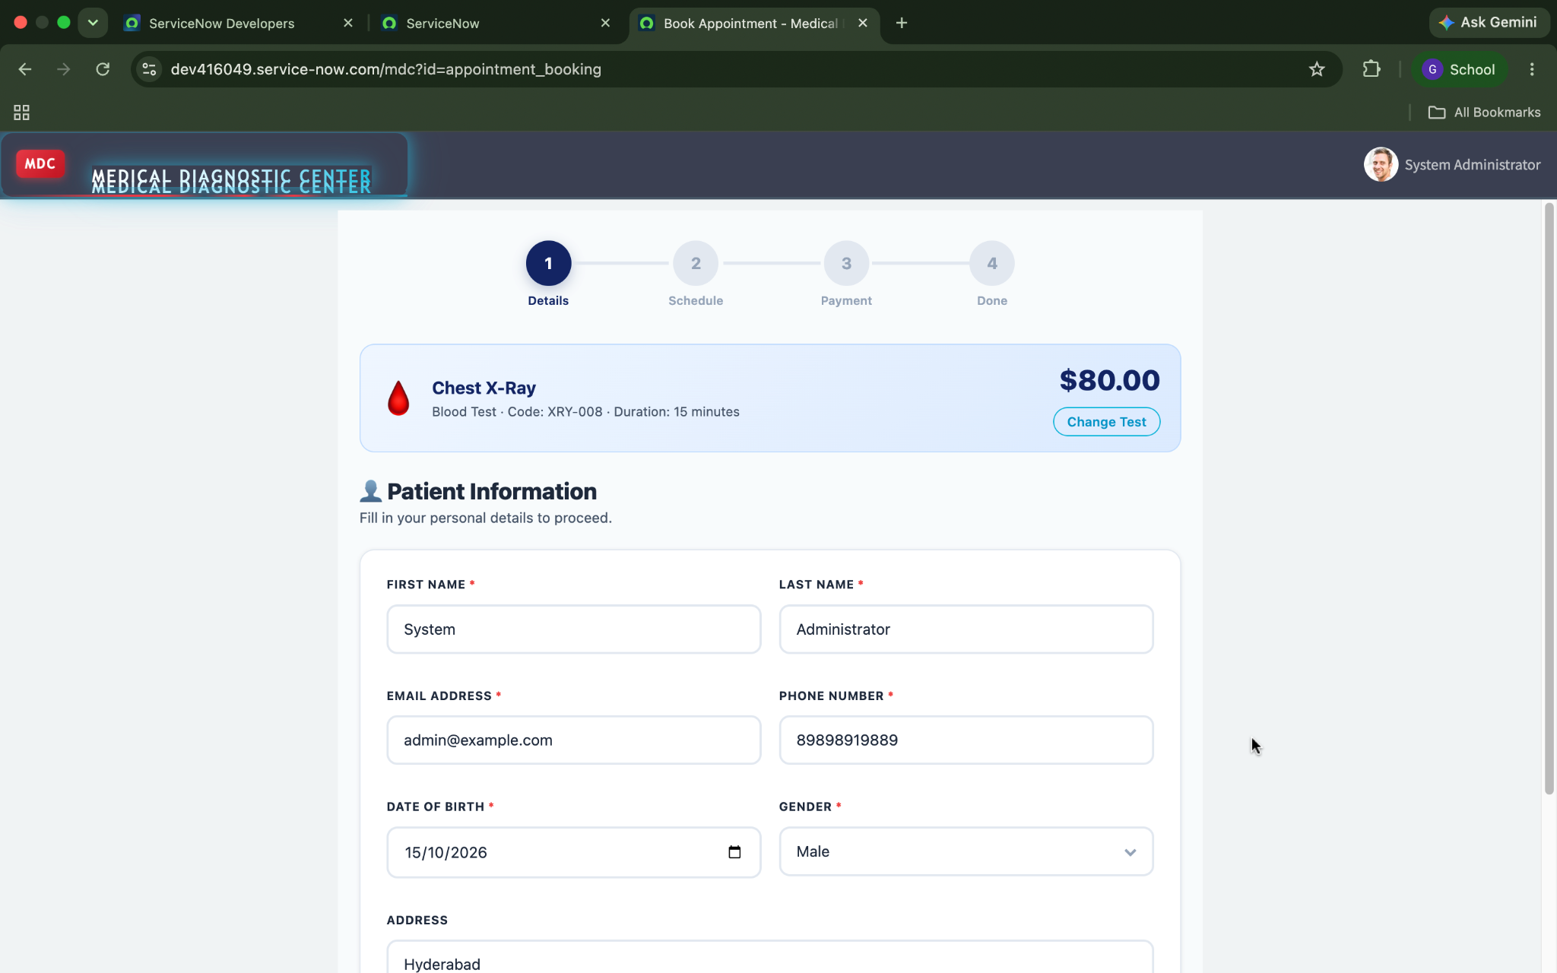
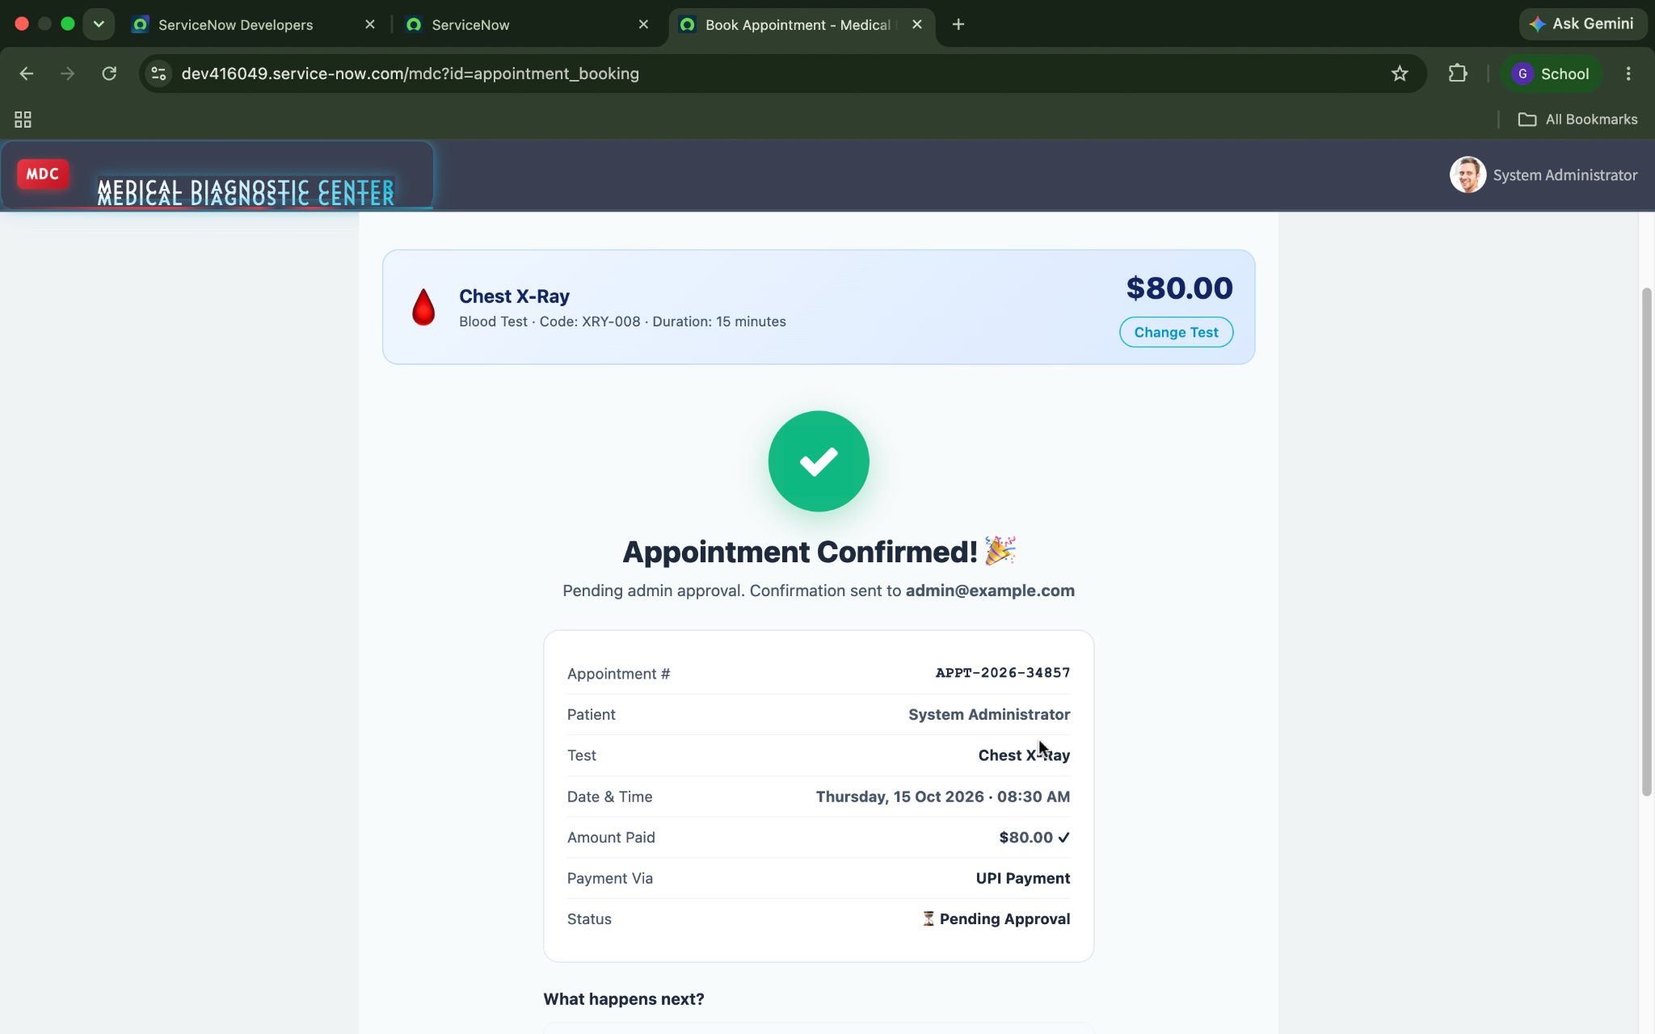

Figure 7. Appointment record with Completed status

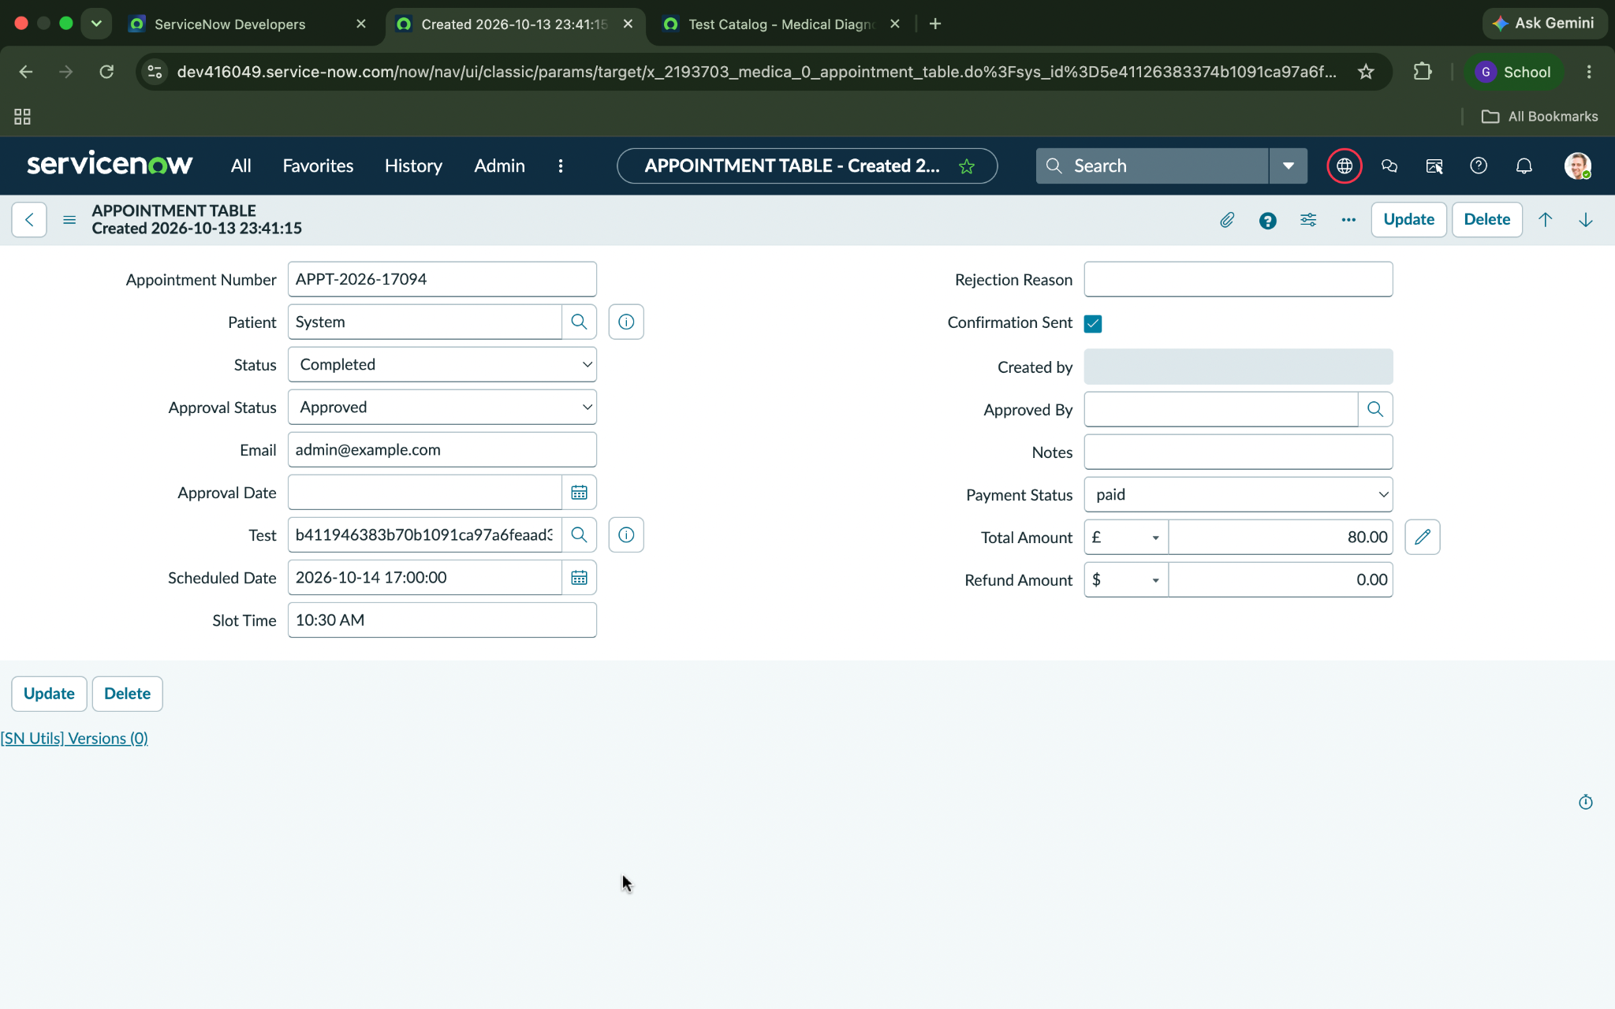

Figure 8. Medical Report record showing findings

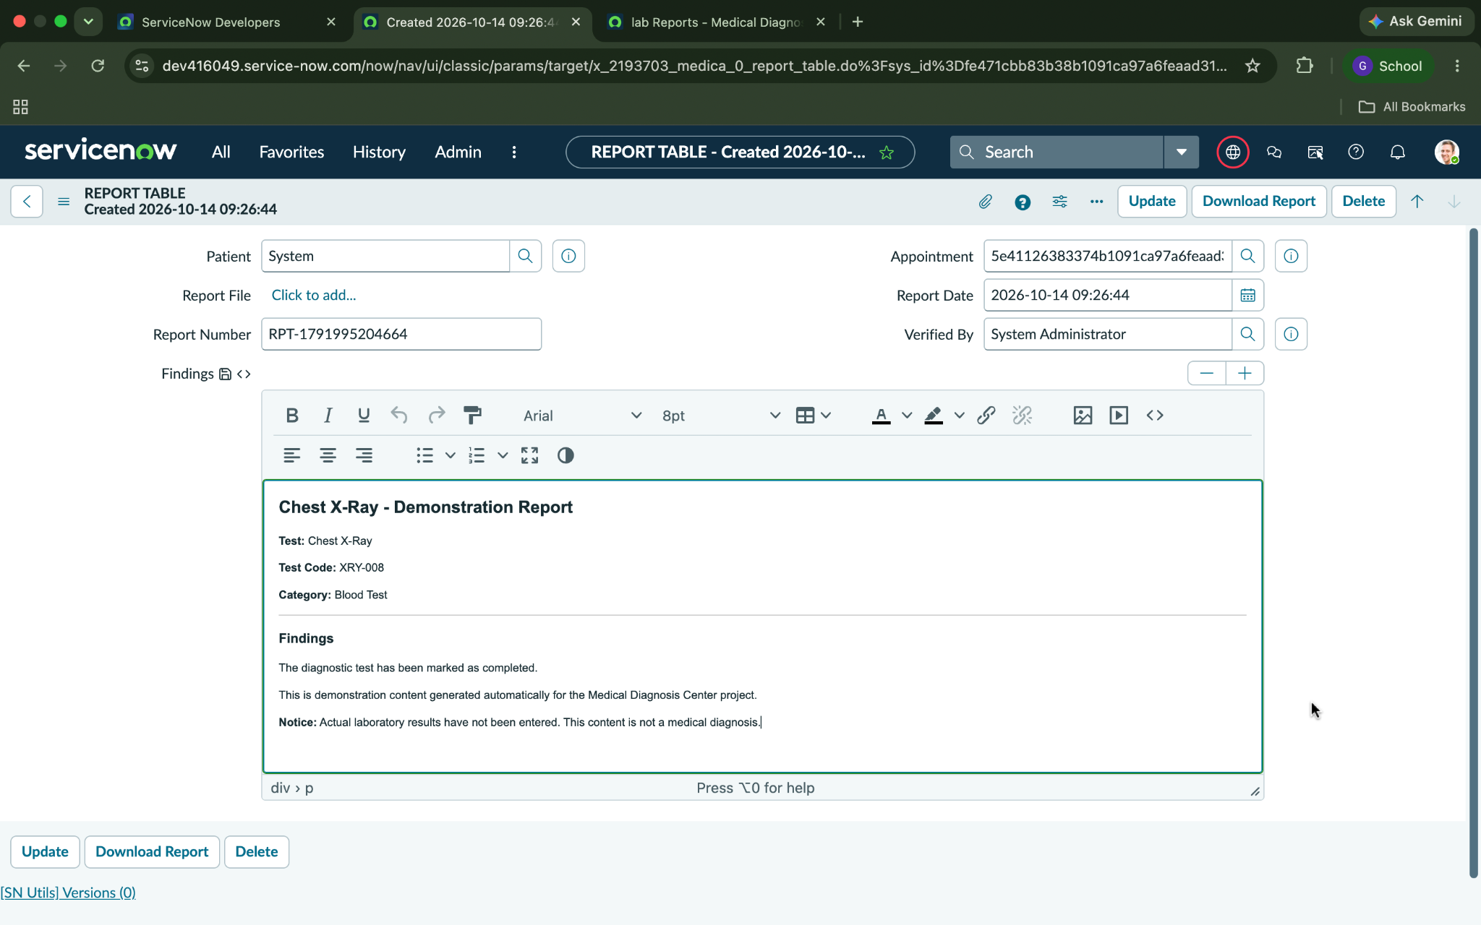
Figure 9. Medical Reports portal page

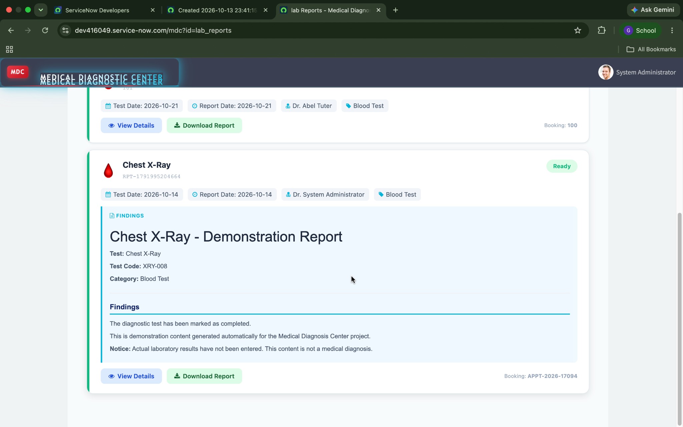
Figure 10. Download / Print Report output

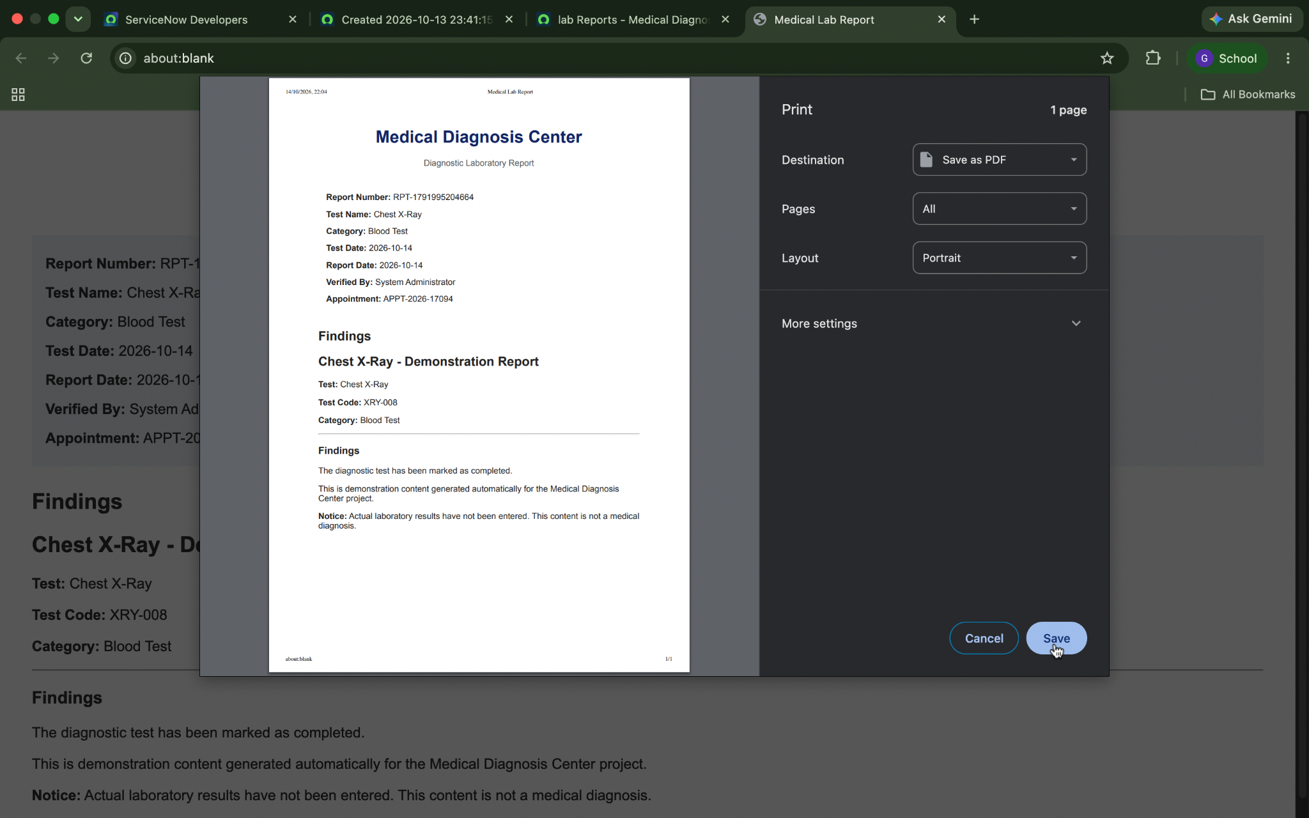

Figure 11. Email Notification

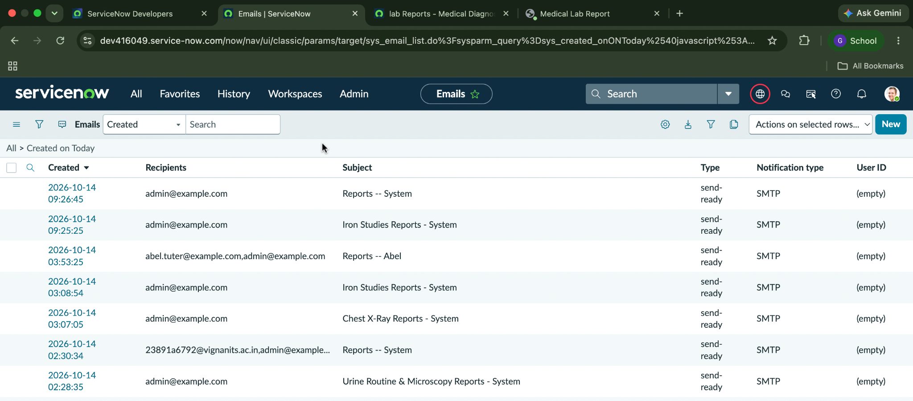

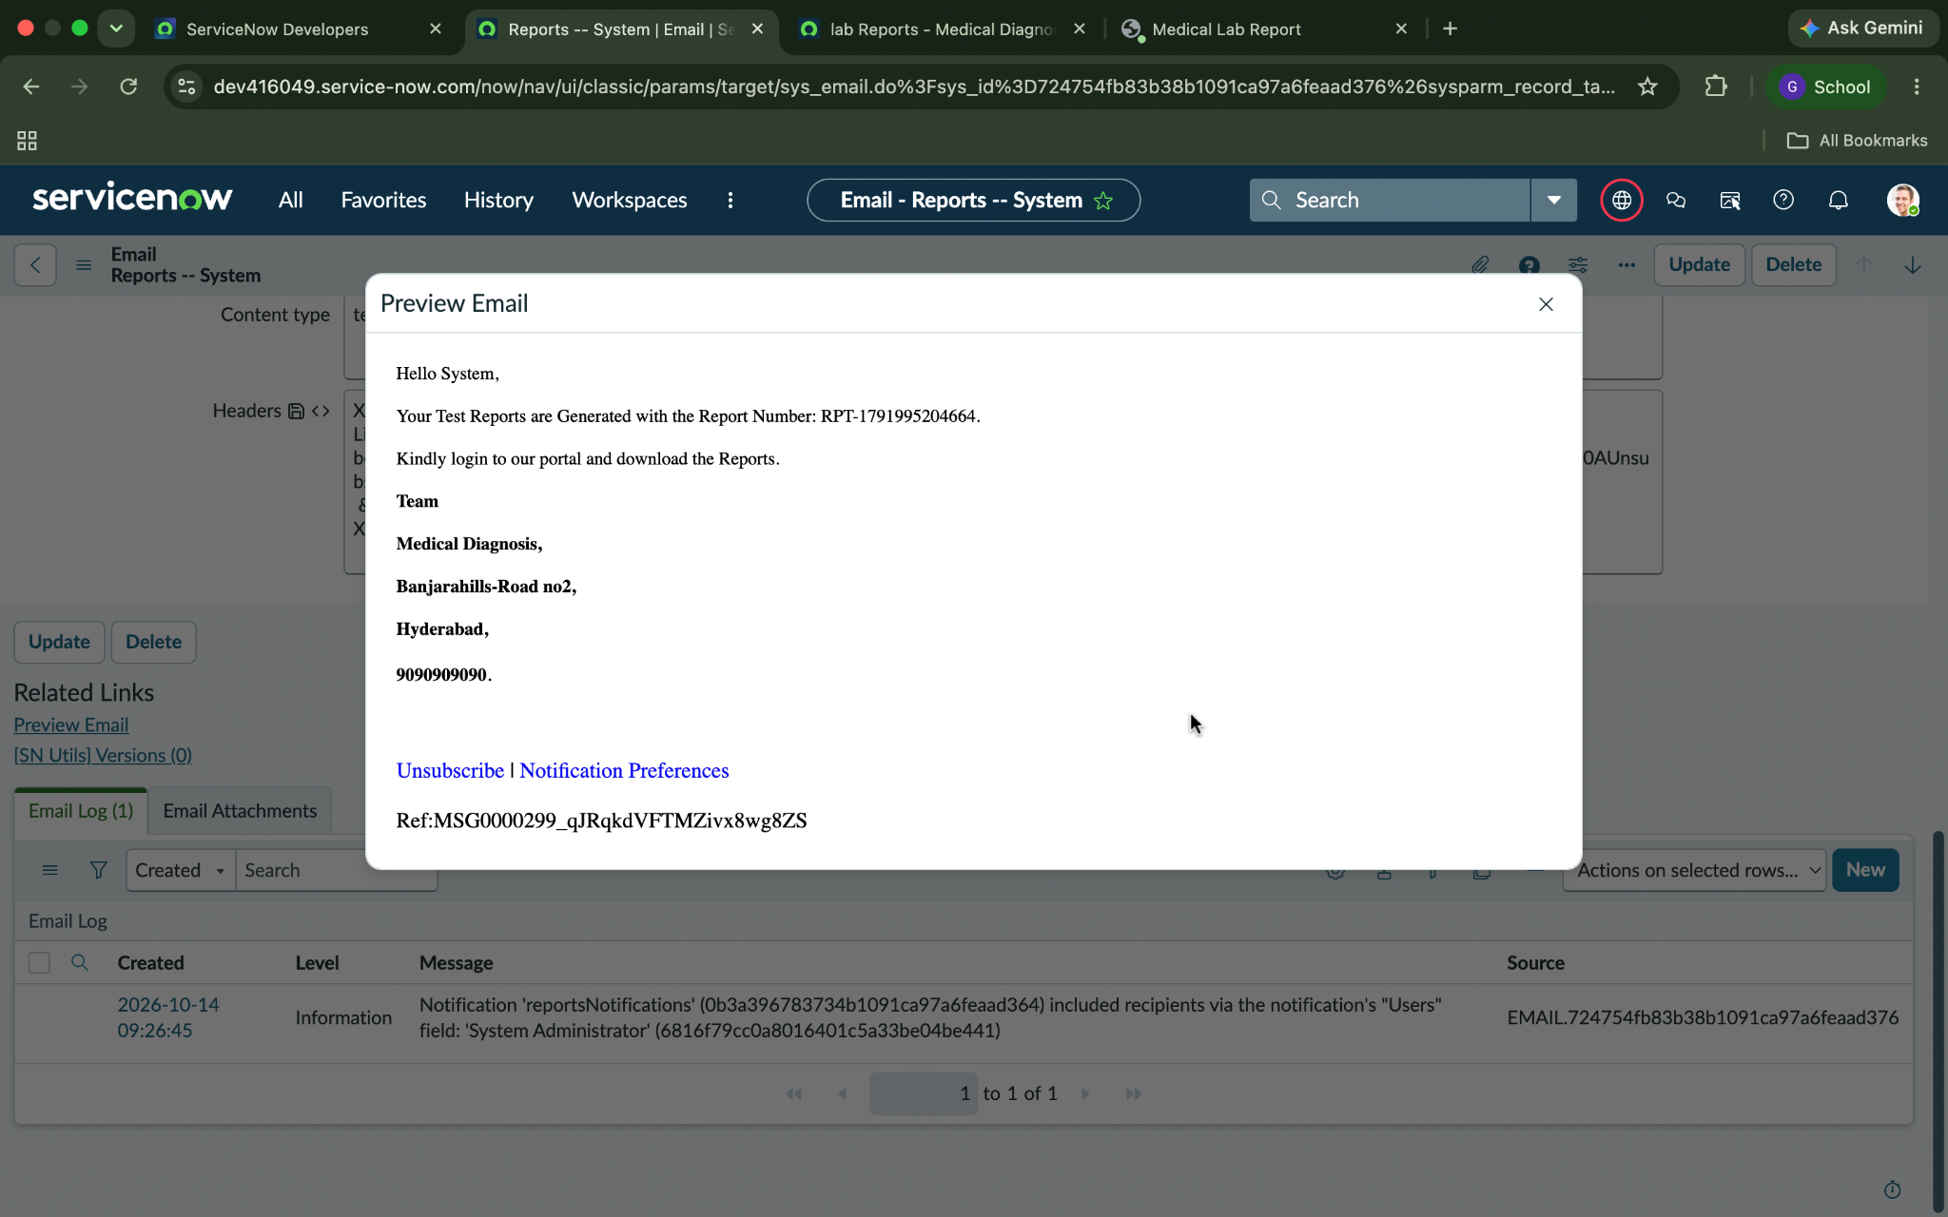

Figure 12 . Dashboard

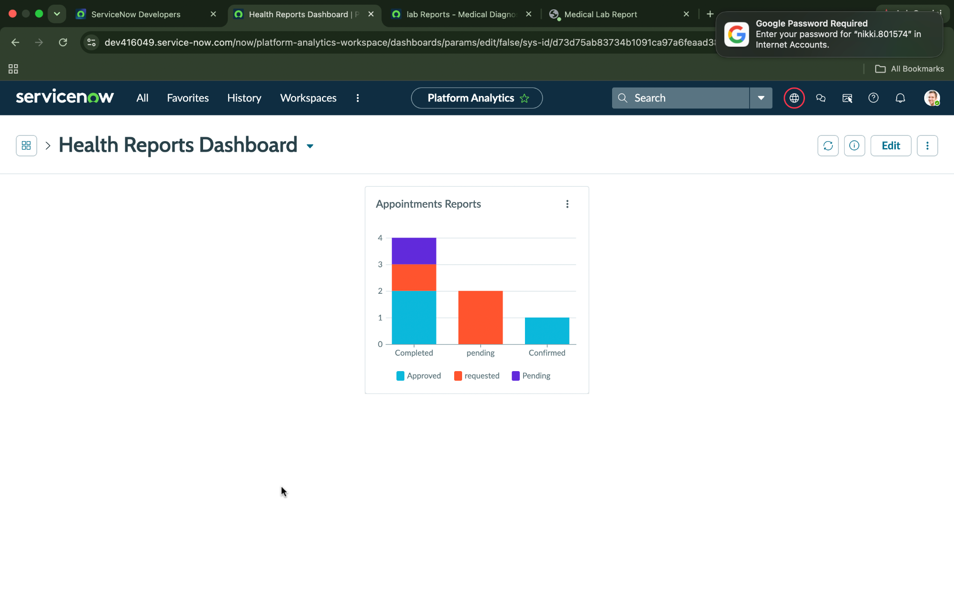
8. ADVANTAGES & DISADVANTAGES

Advantages | Disadvantages / Limitations
Centralizes test, patient, appointment, and report information. | Depends on correct table relationships and field configuration.
Provides a clear appointment-status workflow. | Incorrect status values or conditions can prevent report generation.
Automates creation of report records on completion. | Demonstration findings are sample content and must not be treated as real clinical results.
Role-based access can separate user responsibilities. | Role and ACL permissions require careful testing.
Portal can reduce repetitive status enquiries. | The report download/print behavior needs end-to-end verification.

9. CONCLUSION

The Medical Diagnosis Center project demonstrates how ServiceNow can be used to build a connected diagnostic-centre workflow. Custom tables store the core records, portal pages provide user access, and a Business Rule connects appointment completion with report creation. The project provides a foundation for clearer appointment tracking and report access. Before final deployment or presentation, the team should verify that findings populate correctly, the download/print action works, role permissions are correct, and all test results are documented.

10. FUTURE SCOPE
- Hospital Integration: Connect the application with hospital management systems for better coordination of patient records and diagnostic services.
- Mobile Application: Develop a mobile app for booking tests, tracking appointments, and accessing reports.
- Automated Notifications: Send appointment reminders, confirmations, and report availability alerts through email or SMS.
- AI-Based Assistance: Introduce AI features to provide test preparation guidance and help patients navigate diagnostic services.
- Advanced Analytics: Add dashboards to monitor appointments, laboratory workload, and diagnostic service trends.
- Enhanced Security: Strengthen patient data protection through improved access controls and audit logs.

11. APPENDIX

A. Main Tables

Table | Purpose
Patient — x_2193703_medica_0_patient | Stores patient details
Diagnostic Test — x_2193703_medica_0_diagnostic_test | Stores test names, descriptions, duration, price, and availability
Appointment — x_2193703_medica_0_appointment_table | Stores patient, selected test, scheduled date/time, and status
Medical Report — x_2193703_medica_0_report_table | Stores report number, patient, appointment, report date, findings, verification, and report file

B. Roles

Role | Intended Responsibility
mdc_admin | Manage the MDC application, tests, appointments, reports, and access
mdc_patient | Use the portal to request tests and view own appointments/reports
mdc_receptionist | Register patients and manage diagnostic appointments
mdc_lab_technician | Update sample/testing progress and report status/findings

C. Source Code, Dataset, and Links

Source Code: ServiceNow scripts are maintained in the configured Business Rule and portal widgets. GitHub Link: https://github.com/GNikhila-92/medical-diagnosis-center
ServiceNow Instance: https://dev416049.service-now.com/mdc

